A

PROJECT REPORT

ENTITLED

# “Most Popular IT Companies in India”

# Submitted to

**Dr. Babasaheb Ambedkar Marathwada University,**

**Aurangabad**

# By

**Dinesh Ghodke, Vaibhav Sonkamble,**

**Sandhya Garad and Aavej Mashayak.**

# Under the Guidance of

# Miss. Bhagyashri Kulkarni

# In partial fulfillment of the degree of

**M.C.A (Master of Computer Application)**



**THROUGH**

# Dept. of Management Science,

# Dr. Babasaheb Ambedkar Marathwada University,

**Sub-Campus, Osmanabad**

**2023-2024**

**DECLARATION**

**We, Dinesh Ghodke, Vaibhav Sonkamble, Sandhya Garad and Aavej** **Mashayak** Student of M.C.A. (III SEM) of Dept. of Management Science, Dr. Babasaheb Ambedkar Marathwada University, Sub-Campus, Osmanabad hereby declare that the project entitle **“Most Popular IT Companies in India”** is the result of my own effort and is raised on information collected with my guide.

The project report is correct to the best of my knowledge & this report so far has not been published anywhere else.

**Place Osmanabad Signature of Student & Name**

**Date 23/01/2024 Dinesh Ramhari Ghodke**

**Vaibhav Vishwas Sonkamble**

**Sandhya Sanpat Garad**

**Aavej Mushtak Mashayak**

**CERTIFICATE**

This is to certify that **Dinesh Ghodke, Vaibhav Sonkamble, Sandhya Garad and Aavej Mashayak** has successfully completed the project, as per the course of Master of Computer Application (MCA),Dept. of Management Science, Dr. Babasaheb Ambedkar Marathwada University, Sub-Campus, Osmanabad. He has submitted the project report in partial fulfillment of course for the academic year 2023-24.

DATE:- 23/01/2024

**SUBMITED BY Prof. Suyog Amrutrao Miss. Bhagyashri Kulkarni**

# Head Of Management Science Department Guide By

**ACKNOWLEDGEMENT**

We started this project as a part of our course curriculum. It gives us great pleasure to present the report of this project work conducted towards the fulfilment of the project titled “**Most Popular IT Companies in India**”.

We extent our special gratitude towards Prof. Suyog Amrutrao sir Head of Department of Management Science and Miss. Bhagyashri Kulkarni Project Guide who has been constant source of motivation, encouragement, and guidance that has gone long way in helping the completion of this project. We take this opportunity to thank those who have made the efforts in success of the project. We express our warm wishes to the entire staff members for their assistance and kind guidance who helped us out of all my queries.

We also heartily thankful to all our friends and “Live Life” for providing us all the useful requirements that were needed by us for the completion of project. Our thanks and appreciations also go to our colleague in developing the project and people who have willingly helped us out with their abilities

**INDEX**

|  |  |  |
| --- | --- | --- |
| Sr. No. | Title | Page No. |
| **1.** | **INTRODUCTION** |  |
| 1.1 | Existing System and need for existing System |  |
| 1.2 | Scope of the work |  |
| 1.3 | Operating Environment-H/W, S/W |  |
| 1.4 | Detail Description of Technology Used |  |
| **2.** | **Chapter 2: PROPOSED SYSTEM** |  |
| 2.1 | Proposed System |  |
| 2.2 | Objective of system |  |
| 2.3 | User Requirement |  |
| 2.4 | Feasibility Study |  |
| **3.** | **Chapter 3: ANALYSIS AND DESIGN** |  |
| 3.1 | Module Hierarchy diagram |  |
| 3.2 | Test procedure and implementation  (Test cases and reports) |  |
| **4.** | **Chapter 4: User Manual** |  |
| 4.1 | User Manual |  |
| 4.2 | Operation Manual |  |
| **5.** | **Limitations of the system** |  |
| **6.** | **Future enhancements** |  |
| **7.** | **Conclusion** |  |
| **8.** | **Bibliography** |  |
| **9.** | **Annexure** |  |
|  | Annexure 1: Description of Technology and tools used |  |
|  | Annexure 2: User Interface with data |  |
|  | Annexure 3: Output Reports with data |  |

**1.INTRODUCTION:**

This is the project report on Most Popular I T Companies in India. India is a worlds most IT export. India's IT industry is a dynamic hub, featuring major players like TCS, Infosys, and Wipro, excelling in software development and consulting. HCL, Tech Mahindra, and Persistent contribute significantly to global IT services. Accenture and Mphasis have strong Indian footholds, while companies like Mindtree and L&T Infotech specialize in digital transformation. India's IT sector is recognized for innovation, outsourcing expertise, and its role in global technology advancements.

We included some most popular IT Companies in India to this project those are TCS, Infosys, HCL, Mphasis, Accenture, Persistent, Tech Mahindra, L&T Infotech, Wipro. This project gives a basic information about this most popular IT Companies in India.

**1.1 Existing System and need for existing System**

The "existing system" typically refers to the current operational model or technology infrastructure in place before any proposed changes. While specific details about the existing systems of popular IT companies in India may not be publicly disclosed in great detail, we can discuss general aspects.

Existing System:- Established IT companies in India, such as Infosys, TCS, Wipro, and others, have robust existing systems that encompass a range of IT services, solutions, and client engagements.- These systems are built on years of industry experience, technological expertise, and a deep understanding of client requirements.

Need for the Existing System:

1. Client Base: The existing systems of these IT companies cater to a diverse and extensive client base across various industries globally. The systems are designed to meet the specific needs and challenges of these clients.

2. Technology Infrastructure: These companies have invested heavily in advanced technology infrastructure, including data centers, networks, and cybersecurity measures. This infrastructure forms the backbone of their operations, ensuring secure and efficient service delivery.

3. Innovation and Adaptability: The existing systems emphasize innovation, allowing companies to stay ahead in the rapidly evolving tech landscape. They are designed to be adaptable, incorporating emerging technologies to address changing client demands.

4. Global Operations: Considering the global nature of their operations, the existing systems are designed to facilitate seamless communication, collaboration, and project management across different regions and time zones.

5. Compliance and Security: Compliance with international standards and robust security measures are integral to the existing systems. This is crucial for maintaining the trust of clients and ensuring the confidentiality and integrity of sensitive information.

6. Scalability: The existing systems are designed to be scalable, allowing these companies to handle varying workloads and accommodate growth in client demands. Scalability is essential for maintaining efficiency and performance.

In summary, the existing systems of popular IT companies in India are comprehensive, technologically advanced, and tailored to meet the diverse needs of their global clientele. These systems are the result of continuous innovation, strategic investments, and a commitment to delivering high-quality IT services.

**1.2 Scope of the work**

The IT industry in India offers a multifaceted scope for professionals across diverse domains. In software development, individuals contribute to designing and maintaining applications that cater to a wide array of industries, driving technological advancements. IT consulting roles involve guiding businesses in formulating effective technology strategies and navigating digital transformations to enhance efficiency. The rising importance of data is met with opportunities in data analytics, where professionals analyze and interpret data for informed decision-making. The ever-evolving landscape of cybersecurity presents roles focused on safeguarding systems and data against a myriad of cyber threats. Cloud computing professionals are sought after for their expertise in architecture, deployment, and management of cloud solutions. The realms of artificial intelligence and machine learning see a surge in demand, with professionals developing algorithms and applications for automation. Mobile app development continues to be integral, creating and maintaining applications for smartphones and tablets. Blockchain technology professionals are engaged in implementing secure and transparent systems across various industries. The Internet of Things (IoT) sector provides opportunities to connect devices and systems, enabling data exchange and automation. Quality assurance (QA) professionals play a pivotal role in ensuring software and systems adhere to rigorous quality standards through comprehensive testing. Project management roles oversee the planning, execution, and successful delivery of IT projects. IT support and infrastructure professionals manage the backbone of technological operations, ensuring smooth system functioning. Digital marketing roles utilize online platforms for brand promotion and customer engagement. E-commerce opportunities abound in the online retail sector, involving the management of platforms and logistics. The industry's continuous evolution demands professionals with skills in emerging technologies, fostering innovation and growth.

**1.3 Operating Environment-H/W, S/W**

|  |  |  |  |  |
| --- | --- | --- | --- | --- |
| **Hardware:** | | | | |
| SSD | | : | | 512 GB |
| RAM | | : | | 8 GB |
| Processor | | : | | 11th Gen Intel(R) Core (TM) i3-1115G4 @ 3.00GHz 2.90 GHz |
| **Software:** | | | | |
| Operating System | : | | Windows 11 | |
| Browser | : | | Internet Explorer, Google Chrome | |
| Client-side Technology | : | | CSS, HTML | |
| Software | : | | Subline-text, Notepad | |

**1.4 Detail Description Of Technology used**

**Web Language:**

1.Hypertext Markup Language or HTML: It is a Structural Language used to describe the

structure of information on a webpage. The html file plays a couple of significant roles in a

webpage. In Project HTML is used for Building Layout and Structure.

2. CSS: CSS stands for cascading style sheet. CSS is used for Style the Elements and Page

components.

**Software:**

1. Notepad: Notepad: To write code in HTML & CSS code file.
2. Sublime text: To write code in HTML & CSS code file.

**Chapter 2: PROPOSED SYSTEM**

In the proposed system this project include link for going next page as well as home page for easy visit the page inserted images for showing the IT Industry in India.

Inserting images for showing the IT Companies in India & togethers give the knowledge about the development and growth of the industry.

Objective of system:

To promote and introduce the most popular IT companies in the India.

To Provide search facility of the industry

To promote understanding the IT industry in India.

To give quite knowledge about the Indian IT industry.

* 1. **User Requirement**

.Subline Test

.Notepad

**2.4 Feasibility Study**

A feasibility study of a department of management sciences offering both MBA (Master of Business Administration) and MCA (Master of Computer Applications) programs would typically involve assessing various factors to determine the viability and potential success of such a department. Here are some key considerations:

Market Demand: Evaluate the demand for MBA and MCA programs in the target region or industry. Conduct market research to understand the number of prospective students, their preferences, and the potential competition from other educational institutions.

Target Audience: Identify the target audience for the MBA and MCA programs. Determine whether there is a sufficient number of students interested in pursuing both business

**3:ANALYSIS AND DESIGN**

**Modul Hierarchy diagram**

Most Popular I T Companies in India

(Homepage)

Image

……………..information………………….

Linkings for the next page………..

…..Accenture…..

………HCL……

……Infosys……

….L&T Infotech….

…..Mphasis……

…..Persistent…..

…..TCS……

…..Tech Mahindra…..

…..Wipro….

Accenture

Image

……………..information………………….

Link for go to home page…. Link for go to select page……

HCL

Image

……………..information………………….

Link for go to home page…. Link for go to select page……

Infosys

Image

……………..information………………….

Link for go to home page…. Link for go to select page……

L&T Infotech

Image

……………..information………………….

Link for go to home page…. Link for go to select page……

Mphasis

Image

……………..information………………….

Link for go to home page…. Link for go to select page……

Persistent

Image

……………..information………………….

Link for go to home page…. Link for go to select page……

TCS

Image

……………..information………………….

Link for go to home page…. Link for go to select page……

Tech Mahindra

Image

……………..information………………….

Link for go to home page…. Link for go to select page……

Wipro

Image

……………..information………………….

Link for go to home page…. Link for go to select page……

|  |  |  |  |
| --- | --- | --- | --- |
| Input  descripation | Inserting Image of IT companies | Information of company in India | Linking of particular page |
| Inserting image of Accenture | Information of Accenture | Linking on homepage |
| Inserting image of HCL | Information of HCL | Linking on homepage |
| Inserting image of Infosys | Information of Infosys | Linking on homepage |
| Inserting image of L&T | Information of L&T | Linking on homepage |
| Inserting image of Mphasis | Information of Mphasis | Linking on homepage |
| Inserting image of Persistent | Information of Persistent | Linking on homepage |
| Inserting image of TCS | Information of TCS | Linking on homepage |
| Inserting image of Tech Mahindra | Information Tech Mahindra | Linking on homepage |
| Inserting image of Wipro | Information of Wipro | Linking on homepage |
| Expected in Result | Clicking on homepage companies logo go to this page succesfully | | |

Test Procedure and implementation

(Test cases and reports)

**4 USER MANUA:**

4.1 User manual:

The User Manual contains all the essential information for the user to make a complete use of this Popular I T Companies in India website. The main. purpose of the User Manual is to help the users to get all the required information on the subject that the user guide is on. Every user can get the step by step understanding of the online registration form from this User Manual.

Click on the website.

Then click on the link on the homepage of the page you want to navigate

After going on the requested page click the link of next page to go on the next page or click the link of go to homepage to on the homepage.

Operational Manual:

This system provides information, linking.

The proposed system does not included all famous places in India.

**4.2 Operational Manual:**

This system provides information, linking

**5. Limitations of the System:**

The proposed system does not included all IT companies in India.

It does not provide more information about companies.

Does not provide proper information about the all companies.

**6.Future Enhancement:**

We will include the all the famous IT companies in India in the proposed system.

By using the css we will improve the designing of the system.

By using the google search engine for more information

. We can add some more vedios of Particular IT companies.

We can add the reference of the IT companies.

**7. Conclusion:**

Conclusion IT sector is a major driver of economic growth globally. India's

IT industry is experiencing a strong period of growth, IT sector is the reduced the unemployment in India.

**8.Biblography: HTML, CSC,**

[www.google.com](http://www.google.com)

HTML & CSS : Design and Build – Jon Duckett, 2011.

<https://www.javatpoint.com/html-tutorial>

**9. Annexure:**

Description of technology and tools:

In this project we have used four types of computer software languages HTML, PHP, CSS & JavaScript.

This all project is created using Four Software’s Notepad, Sublime Text and and

for Checking we have used Chrome Browser.

Software Languages: HTML, CSS

Web Language - Hypertext markup language, or HTML is a Structural Language used to describe their work with collaborating with each other. In Project HTML is used for Building Layout and

Structure, CSS is used for Styling the all elements and Fonts & Images and is Used

**Hardware Requirements:**

• CPU

• Monitor

• Key-Board

• Mouse

• Network Connection

**Software Requirements:**

• Sublime text

• Notepad

• Chrome Browse

**User Interface With Data Source Code:**

**Homepage:**

**HTML**

**<!DOCTYPE html>**

**<html>**

**<head>**

**<title>TOP 10 IT COMPANY IN INDIA</title>**

**<link rel="stylesheet" type="text/css" href="itcompanyphoto.css">**

**</head>**

**<body >**

**<div class="bg">**

**<h1>_______________Most Papular I T Companies In India_______________</h1>**

**<hr>**

**</div>**

**<main>**

**<div class="box"><a href="accenture.html" target="_blank">**

**<img src="image/accenturelogo.jpg" alt="accenture.html">**

**</a></div>**

**<div class="box"><a href="HCL.html" target="_blank">**

**<img src="image/hcllogo.jpg" alt="HCL.html">**

**</a></div>**

**<div class="box"><a href="Infosys.html" target="_blank">**

**<img src="image/infosyslogo.jpg" alt="Infosys.html">**

**</a></div>**

**<div class="box"><a href="L&T.html" target="_blank">**

**<img src="image/ltlogo.jpg" alt="L&T.html">**

**</a></div>**

**<div class="box"> <a href="Mphasis.html" target="_blank">**

**<img src="image/mphasislogo.jpg" alt="Mphasis.html">**

**</a></div>**

**<div class="box"><a href="persistencetchnology.html" target="_blank">**

**<img src="image/persistentlogo.jpg" alt="persistencetchnology.html">**

**</a></div>**

**<div class="box"><a href="tcs.html" target="_blank">**

**<img src="image/tcslogo.jpg" alt="tcs.html">**

**</a></div>**

**<div class="box"><a href="tech mahindra.html" target="_blank">**

**<img src="image/tmlogo.jpg" alt="tech mahindra.html">**

**</a></div>**

**<div class="box"><a href="wipro.html" target="_blank">**

**<img src="image/wiprologo.jpg" alt="wipro.html">**

**</a></div>**

**</body>**

**</html>**

**Output Report with Data:**

**1.Home page:**

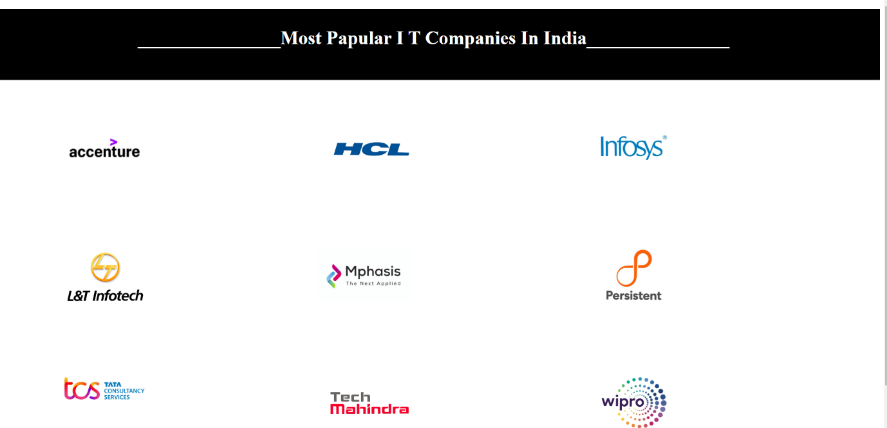

**2.Accenture:**

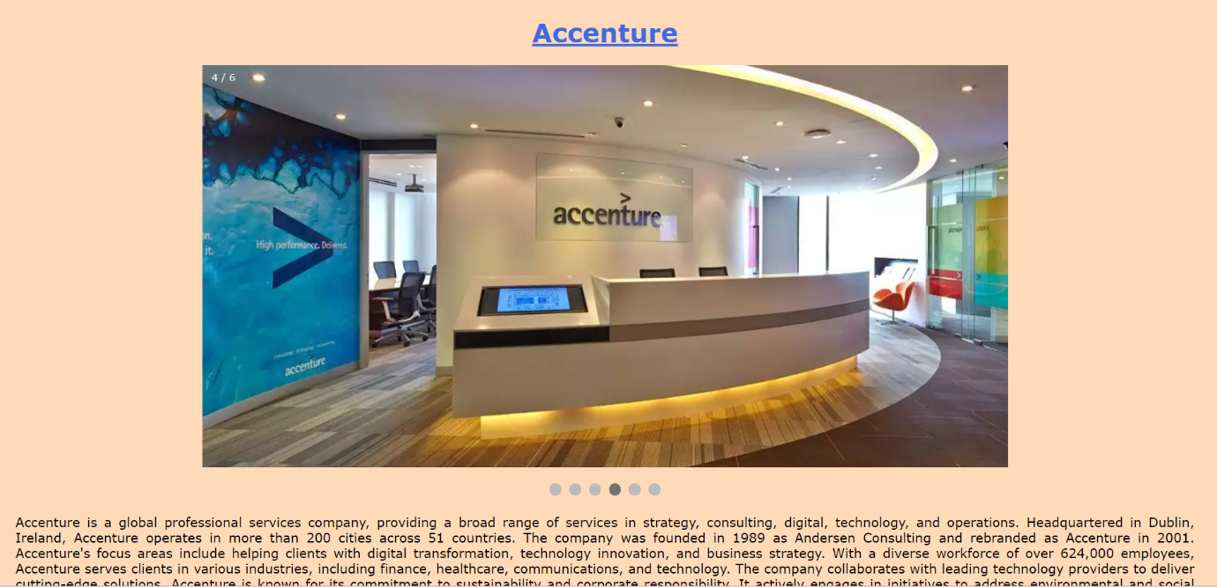

**3.HCL:**

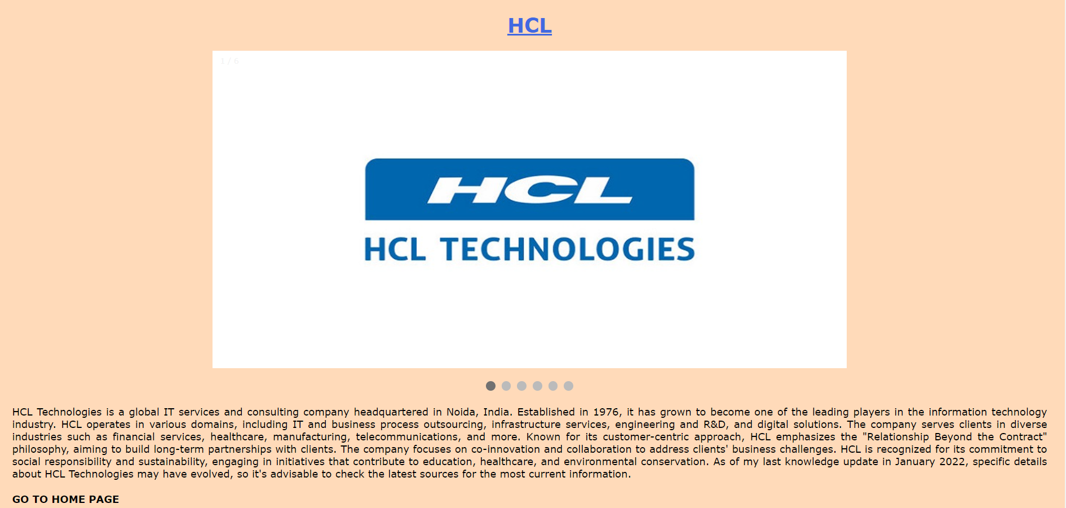

**4.Infosys:**

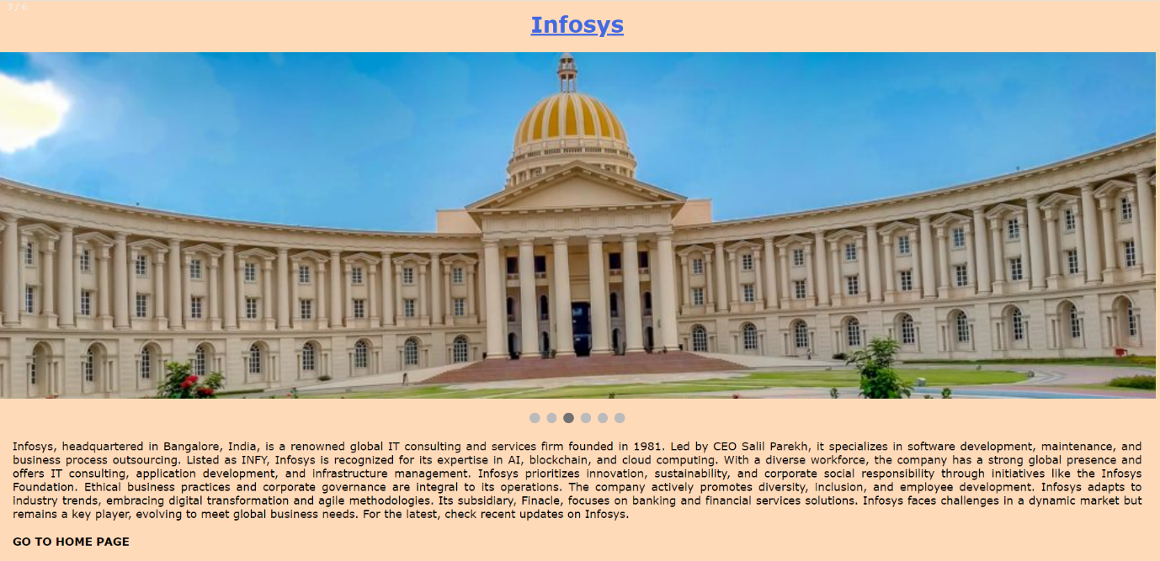

**5 L&T Infotech:**

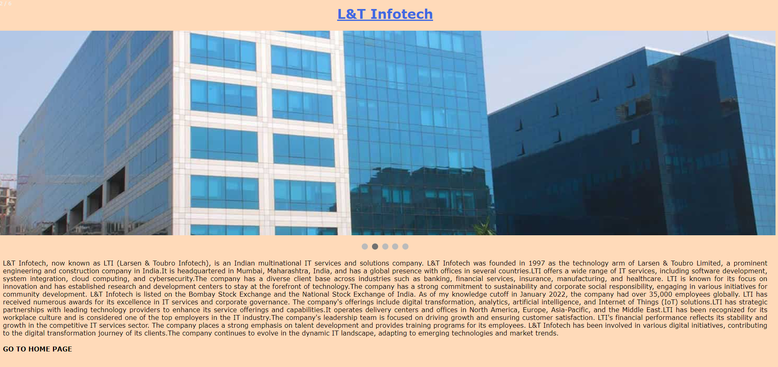

**6.Mphasis:**

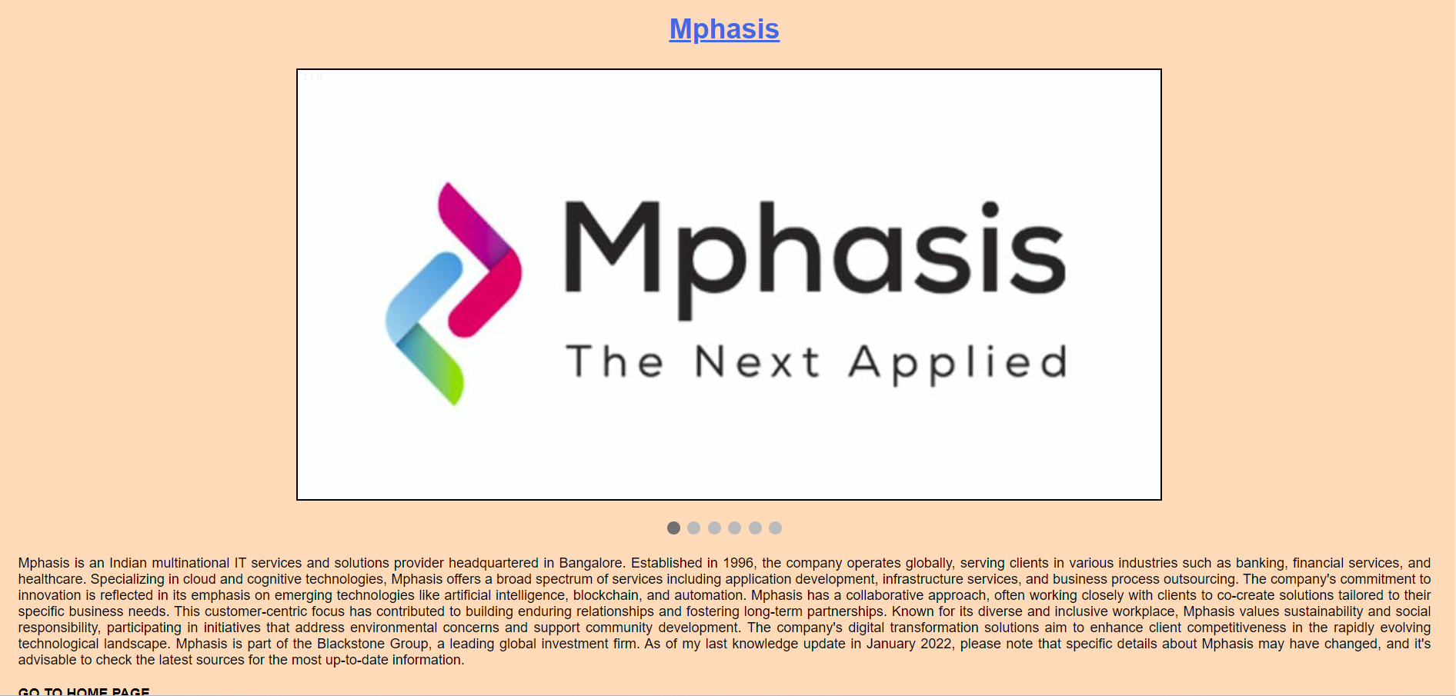

**7. Persistent:**

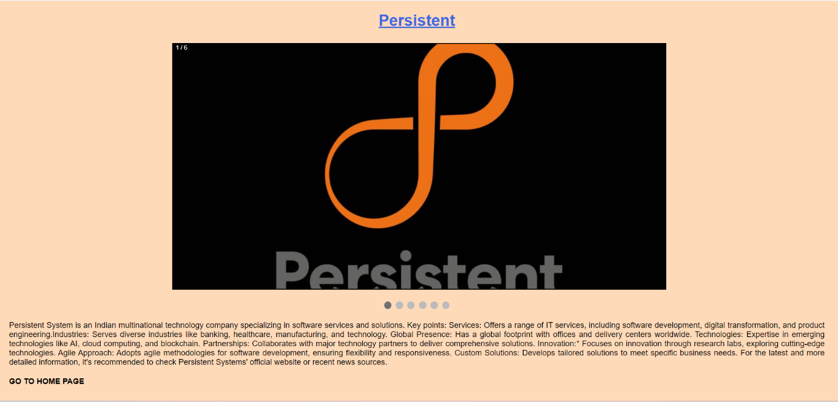

**8. TCS**

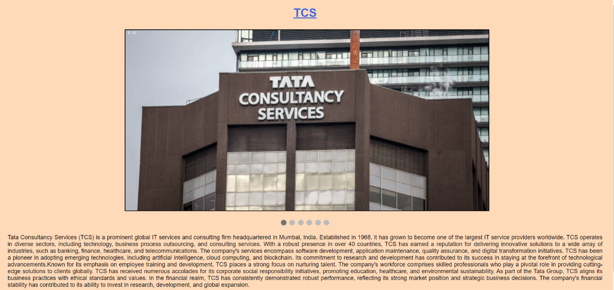

**9.** **Tech Mahindra**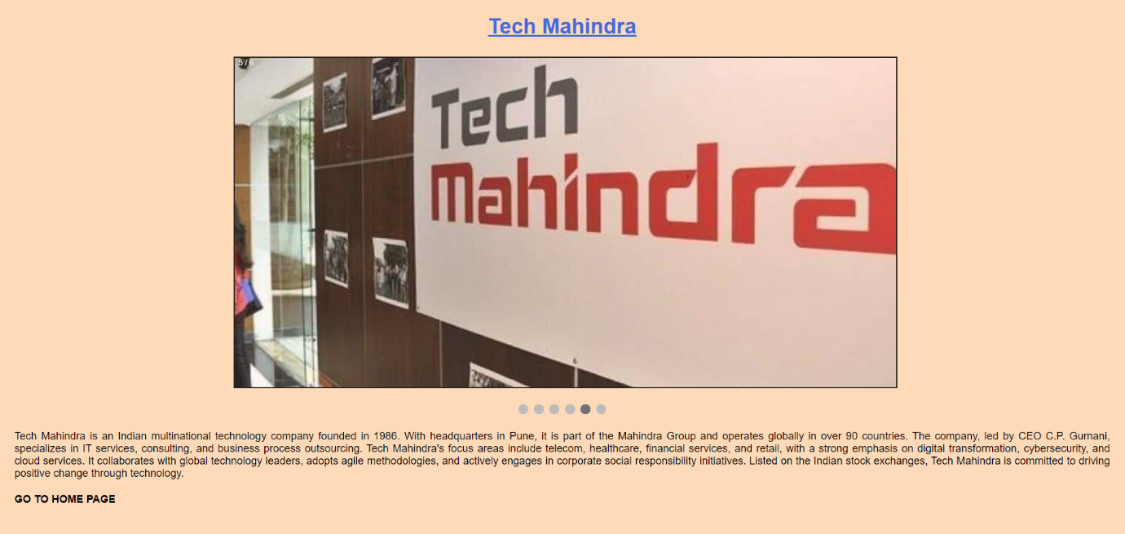

**10. Wipro**

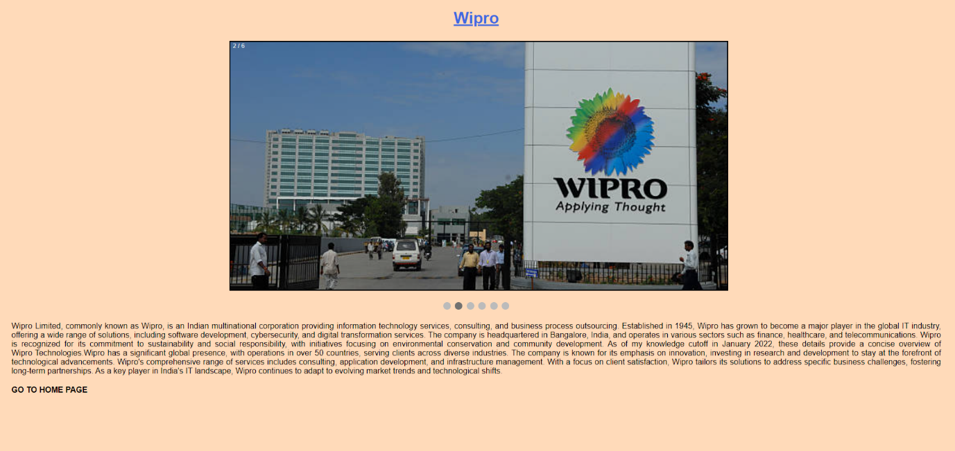

**Thank You**